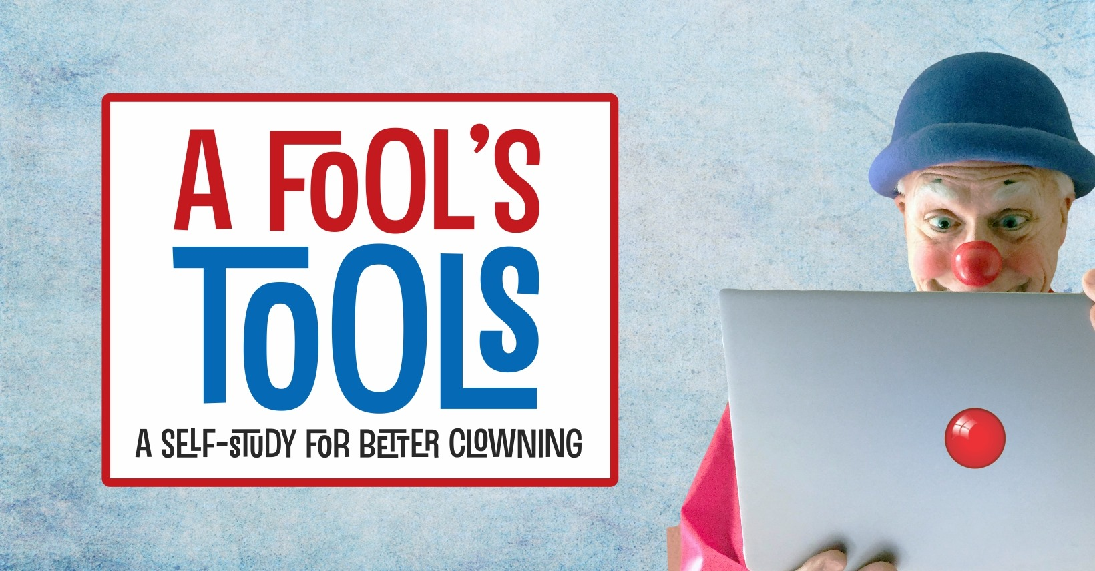
“In the middle of difficulty lies opportunity.”
– Albert Einstein

Who better to face difficulty head on and turn it into an opportunity than the clown?

When you read this article, you, your community, and your performing art of clowning will still be hunkered down in a prolonged battle against the coronavirus pandemic. Social distancing. Economic uncertainty. No live audiences.

If you’re a frontline medical or healthcare worker, you’re running a marathon that keeps moving the finish line. If you’re a teacher, you now greet your students online. If you’re a full-time entertainer, it kind of feels like time out without a timer.

But there’s a silver lining in this dark cloud of anxiety . . . a gift of time.

Here’s a way to use that time constructively and improve your clowning. It’s called A Fool’s Tools – A Self-Study for Better Clowning.

A Fool’s what?

A Fool’s Tools is a 21-day self-study program to make you a funnier, better clown. Daily reading, reflection, viewing, and practice will focus on where you want to improve your clowning.

The Fool’s Tools program uses resources you’ve got available to you – your clown mind, body, and soul, your goals and aspirations as a performer, print materials like books and magazines, online sources like Facebook and YouTube, your thoughts and observations, and your friends and colleagues in the clown community.

What are the goals of A Fool’s Tools?

1. Learn what’s funny (to you).
2. Learn new performance skills
3. Increase your knowledge and proficiency in your chosen study area.
4. Develop new habits for improving your art.

If you had (and dedicated) 21 days to improve your clown and clown performance, what would you work on? You could:

- Discover what makes you laugh
- Update and transform your look and character
- Create a voice or walk for your clown character
- Learn a new clown performing arts skill or discipline – e.g. juggling, walk-around bits, pocket magic, playing a musical instrument, singing, storytelling, improvisation, therapeutic clowning, physical comedy, comedic movement
- Improve a current skill
- Learn a new clown business skill – e.g. marketing, graphic design, costume construction, prop construction, public speaking
- Study and learn the history of clowning
- Study the works of classic and modern-day master clowns
- Develop a theme show
- Write new material that truly springs from your authentic clown character
- Create a new workshop to teach a clown performing arts skill to others
- Build a plan to kick start your clowning post-pandemic

Even if you're busy with a job and family, this self-study is doable. It’s also challenging, fun, rewarding, and, best of all, personalized to your interests and needs.

First ask yourself, “What do I want to get out of this 21-day self-study?”

That’s your purpose, your focus, your goal. Goals should be meaningful and relevant to you and your clown development. They also should be dreamable (inspiring and motivating), believable (realistic), and achievable (measurable).

One way to set your self-study goal(s) is to use the SMART approach. Make sure they are:
Specific, Measurable, Achievable, Relevant, and Time limited (remember, you’ve got 21 days).

Or, make them SMARTER by adding Evaluated (for accountability) and Reviewed (through coaching, feedback, and support).

For example, I set these goals for my own recent 21-day self-study:

1. I will read at least 10 comic strips every morning, and journal what was funny to me.
2. I will read and annotate “Medical Clowning, the Healing Performance,” by Amnon Raviv, for application in hospital clowning.
3. I will practice the concertina every day in order to build enough proficiency to start taking lessons.
4. I will journal every day to reflect on what I could apply to and improve my clowning.
5. I will review my self-study plan with a coach/mentor at the beginning, during, and conclusion of the 21-day study period.

Here’s what you’ll need

Here are the materials, resources, and clown stuff you’ll need for your self-study:

1. Goals – discussed in the previous section
2. Notebook – either electronic or paper-and-pen to use as your daily journal
3. Daily comics – online, print newspaper, or delivered by e-mail
4. Reading material – book(s) or Internet resources that are informational, instructional, research, or inspirational related to clowning and your chosen study
5. Viewing material – movies, TV shows, videos, YouTube, online workshops
6. Physical space(s) – for reading, study, writing, and practicing
7. Support – coach, mentor, instructor, family, friend, alley, or collegial group
8. Time and commitment – you may need to negotiate for the time, but committing to it is up to you

You’ll have at least three study periods each day for a 21-day period:

1. Morning funnies
2. Reading and reflection
3. Practice/workshop
4. (Optional) enrichment activities

Each of those study periods has a time frame and a task.

1. Morning funnies (10-15 minutes)
Assignment: Read the daily comics. Choose at least 10 to read every day. You may need to read a whole bunch, or all of them to start, to discover what you like and what makes you laugh. GoComics.com is a great resource if you don’t have access to the daily funnies in a print or online newspaper. Comment on those you enjoy and those that make you LOL (you’re learning what makes you laugh).

2. Reading and reflection (15-30 minutes)
Assignment: Read a section of the book you’ve chosen every day (you could spread the entire book over a 20-day period and summarize on the 21st day), relevant magazines or journals, or the online material you’ve chosen to study. Record your thoughts.

3. Practice/workshop (15-60 minutes)
Assignment: Hold an active workout, rehearsal, or practice session. Practice, practice, practice a new skill, move, or routine. Perform a work-in-progress in front of a video camera or a coach or friend. Journal your thoughts.

4. (Optional) enrichment activities (30-60 minutes)
Possible activities: View a movie or video that relates to your chosen field of study. Sit down to some classic Charlie Chaplin, Buster Keaton, or Harold Lloyd. YouTube master clowns of the modern era, like Bill Irwin, Avner the Eccentric, Red Skelton, Mr. Bean, or Oleg Popov. Watch a children’s TV show. You may have to research what kids are watching these days (and discover which of the classics they still enjoy). Then watch several to see what kids like and find engaging, entertaining, and funny. Attend an online workshop or Zoom session. Try a new idea that came out of an earlier practice session or reading or video. Write down your observations and reflections.

How you’ll learn: Observe, reflect, apply, then do

Your Fool’s Tools Self-Study is based on a pretty simple learning model:

Observe – reading material, watching videos, viewing yourself try something new
Reflect – thinking about how that made you think, feel, act, laugh, discover, question
Apply – taking what you’ve observed and looking at how it might work for you
Do – putting what you’ve learned into practice and performance

Why take the time to reflect on an experience? It helps you understand its meaning and impact. It makes you think like a clown, always curious and exploring and growing.

Here’s a way to reflect on each of the different episodes of your clown self-study. Ask yourself questions like these after individual study periods, at the end-of-the-day, or both:
- What made me laugh?
- What made me curious?
- What surprised me?
- What did I learn?
- What was the best thing that happened today?
- What do I want to do tomorrow?

What’s in it for you? Better clowning

The intent of A Fool’s Tools Self-Study is to fine-tune your sense of humor, build new clown performance skills, improve proficiency and self-confidence in your current skills, create new positive habits and practices, and maybe discover what you’re good at . . . in other words, make you a better clown.

Whoa! That’s a ton of good stuff to come out of the next 21 days!!

Sound challenging? It should be. Sound exciting? It will be!

So, are you ‘in’ on devoting the next 21 days to making yourself a better, more complete clown? Want to make the commitment of time, focus, and energy to a Fool’s Tools Self-Study for Better Clowning?

Then, let’s go! Grab your notebook. Set some goals. Identify the online or print resources and media you’ll need. Find someone to support you. Commit the time.

And commit to improving your clown and your clown performing.

Then, let’s meet back here in 21 days and talk about how we’ve become better clowns.

Mike Bednarek is a physical comedian (Buster) and hospital clown (Dr. Fun E. Bone) who lives in Salem, Oregon. He is a work-in-progress in his 40th year of clowning.

