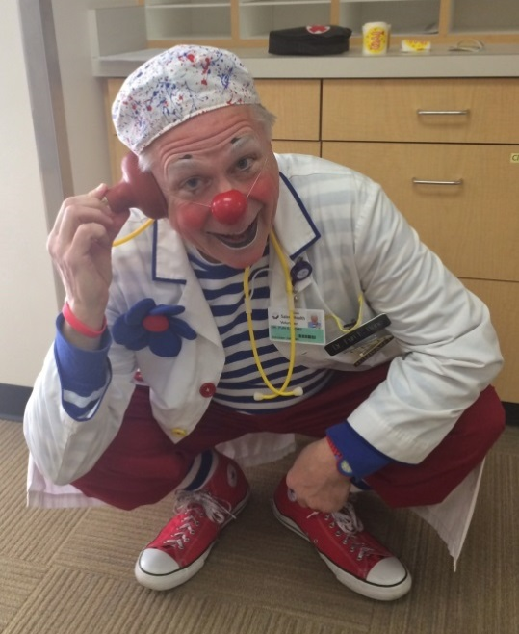
“In the Zone” – Mind and Body in Synch
Mike “Buster” Bednarek

Dr. Fun E. Bone, my hospital clown character, has been doing weekly clown doctor rounds at the local hospital for almost a year now. Recently, I have found myself “in the zone,” a magical place where my clown mind and body, thoughts, actions, and feelings all seem to be working together in unison, perfectly in synch with the moment and the environment.

Time seems to stand still. Three-and-a-half hours into my usual 2-hour shift, I glance at a clock for the first time and realize how the time has flown effortlessly by.

“In the zone”

“In the zone” is that place where gifted and accomplished performing artists (WAY more so than I am!) say everything slows down for them, where it feels like the performance is playing out in slow motion. They can anticipate what’s going to happen, moving in synch with the flow of the performance as some sort of creative, playful spirit.

“In the zone,” Dr. Fun E. Bone is fully present, with a heightened sense of being in the moment. Every interaction – patient, visitor, medical staff, support staff, fellow volunteer – feels genuine and engaging. Everything works – patter, non-verbal stuff, magic, cards, lampoons of medical procedures, improvisational physical comedy. Nothing feels rushed, and there’s an effortless, spontaneous flow to it. (The ancient Roman poet Horace said it best: “Don’t think, just do.”)

Whoa! This has been a surprising, unexpected, and somewhat unsettling evolution for me!!

Hospital clowning is hard work!

Since beginning work as a volunteer clown doctor last summer, my clown character and skills and comfort levels have been tested and pushed and stretched. While I’ve been a clown for almost 35 years now (still, obviously, a work-in-progress, as we all should be), I’ve done most of my clowning as a physical comedian on various stages and venues. But as a clown doctor, I’m now engaging people one-on-one, doing close-up work, using a character voice, and clowning at energy levels appropriate to a hospital setting. This has been HARD work! (Kudos, winks, and a tip of the hat to those of you who have been doing this kind of work for years . . . you have my utmost red nose respect!)

Recently, though, something clicked. Dr. Fun E. Bone seems to have found his performance pocket. At ease, yet totally engaged and focused. Calm, yet intense and exhilarated.

Could that leap have been prompted by as simple an act as incorporating a new costume – clowny lab coat and hot tamale red scrub pants? It certainly seemed to turn the inner fire up a bit, and the audiences – patients, families, staff, and other volunteers –have responded in-kind.

Perhaps it played a small role, pulling together character, appearance, function, audience engagement, purpose, and setting. But I think there’s a lot more going on here than a simple costume change, and more than just serendipity that mental and physical and spiritual performance levels have been pushed or lifted higher.

Clowning “in the zone”

What can we do as performers to achieve this kind of peak performance state? How can I stay there or get back “in the zone” next time – or every time – I clown? Here are a few thoughts:
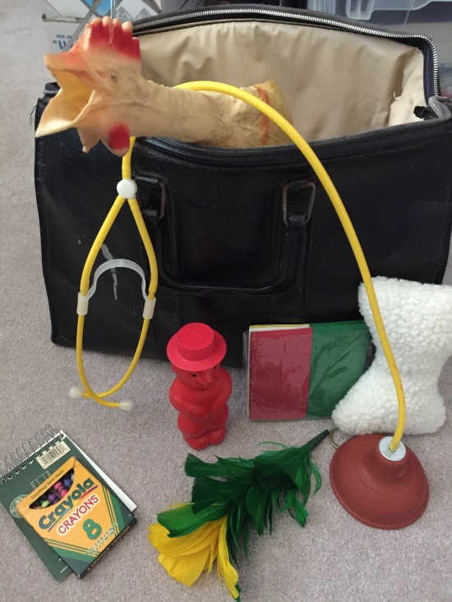
1. Preparation.
Preparation, practice, and repetition make it possible to perform without thinking about what you’re doing, as well as improvise when faced with new and different situations.

2. Skills fit.
Skills and ideas built up from all your past experiences can contribute toward a comfortable, natural fit with the role you’re playing or the setting in which you’re performing.

3. Presence.
Confidence in your character and skills help convey a strong, positive, and calm presence and allow you to perform at ease ‘in the present.’ Your focus is genuine, locked in, and in-the-moment.

4. Spontaneity.
Are we open to – and ready to embrace and play with – the gifts of inspiration, unforeseen challenges, spontaneous changes in direction, moments of grace, and serendipity that our audiences and settings give us? We have to trust our own clown instincts and audience dynamics to light the path of shared play and give each new ‘audience’ the reins to the rhythm and flow of our time together.

What do you think?

Have you felt “in the zone” in your clown performances or appearances? What makes you feel so focused and calm and confident, like time was standing still? How often does this occur? Was there something in particular that you can point to that led to such a heightened performance level? What can we do as performers to increase the chances that we’ll find ourselves “in the zone” in future performances?

Keep calm and clown on, my red nose friends! May you be filled with inspired foolishness wherever you clown.

Mike “Buster” Bednarek tours throughout the Pacific Northwest with his zany mix of physical comedy and illusions called Buster’s Red Nose Revue. He’s served on the staff at numerous clown camps, festivals, and conventions. After a 34-year career in Oregon schools, and before he grows up, he’s now clowning full-time. In his spare time, he bikes without falling, squeezes the concertina with mixed results, and gets taken for frequent walks by his dogs. Visit him on the web at www.bustertheclown.net or www.facebook.com/BustertheClown.

